Photo browser spec

1. Load a XML file with metadata: https://dl.dropboxusercontent.com/u/90314326/photos.xml
   1. The metadata describes set of items
   2. Each item has several fields:
      1. Id: unique id of the item
      2. url: the url for the image
      3. title: a shot description of the item
2. Build a list from that metadata. Should look like this:  
   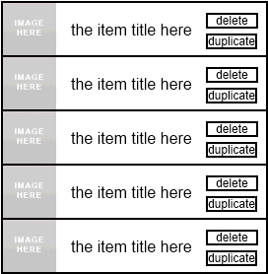
3. Download images (thumbnails) for each item in the list meanwhile present a loading image: loading.png
   1. To load Thumbnail url, add ‘**_s**’ at the end of the image name. Ex:

http://farm1.staticflickr.com/2/1418878_1e92283336**_s**.jpg

* 1. Note: an image can be presented more than once –same url might be shared between several items

1. Each item row has 2 buttons: duplicate and delete.  
   where:
   1. duplicate – duplicates the item into a random position in the list (might be below or above the current item position)
   2. delete – delete the item
2. Pressing on the item row should present an item details screen. Should look like this:  
   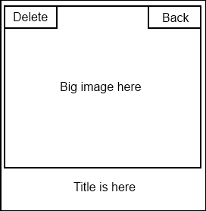
   1. The big image (url) should download and presenting here
   2. Item title should be presented at the bottom of the image
   3. Delete button: deletes the item and return to list
   4. Back button: returns to list
3. General note: **Think of the UX – best performance** (hint: image loading time)
4. You should spend no more than 4 hours to get this done